AUTHOR: Justyna Kluska

cHARACTERS WITH SPACES:

**48 000**

dATE OF SUBMISSION:

|  |  |
| --- | --- |
| A picture of a winding road and trees  semester project  Touchless candies dispenser | Abstract  [Draw your reader in with an engaging abstract. It is typically a short summary of the document. When you’re ready to add your content, just click here and start typing.] |

**Summary**

Table of Contents

1. Introduction 3

2. Requirements 4

3. Methods and Tools 4

4. Hardware 4

5. Modules 4

5.1 Module 1 – Arduino MEGA 2560 4

5.1.1 Module 1 Design 4

5.1.2 Module 1 Implementation 5

5.1.3 Module 1 Test 5

1.1 Module 2 – TCS3200 Color Sensor 5

5.2.1 Module 3 Design 5

5.2.2Module 3 Implementation 5

5.2.3 Module 3 Test 5

5.3 Module 3 – Servo Micro Motor 6

5.3.1 Module 3 Design 6

5.3.2 Module 3 Implementation 6

5.3.3 Module 3 Test 7

5.4 Module 4 - VL53L1X Time-of-Flight Distance Sensor 8

5.4.1 Module 4 Design 8

5.4.2 Module 4 Implementation 8

5.4.3 Module 4 Test 8

5.5 Module 5 - WS2811 5050 RGB LED Strip 8

5.5.1 Module 5 Design 8

5.5.2 Module 5 Implementation 8

5.5.3 Module 5 Test 8

6. System Integration 8

6.1 Design 8

6.2 Implementation 8

6.3 Test 8

7. Prove 8

8. Perspective/ Reflections 8

9. Conclusion 8

10. Appendices 8

# Introduction

Introducing an innovative touchless candy dispenser, a unique, funny device that offers numerous advantages. Do you have your favorite flavor of candies like M&M's or Skittles? Thanks to the sorting function, you can now easily select your preferred candies first. Furthermore, the candy dispenser is touchless, prioritizing hygiene, especially in a post-COVID world. Whether you're sharing your candies with family or a group of friends, it's crucial to remember about cleanliness. Whether you're hosting a party, searching for a unique surprise for your child, or aiming to stand out on Halloween, the Touchless Candy Dispenser is the must-have accessory that brings joy, convenience, and hygiene to any occasion.

Bottom of Form

# Requirements

The requirements of project 4 are very broad in terms of the choice of the final product and its components. However, the main objective is to deliver a self-built and programmed product that performs a specific activity. It is crucial to apply the skills acquired during the 3rd semester, demonstrating practical know-how in the design, implementation, and testing phases of the project.

# Methods and Tools

# Hardware

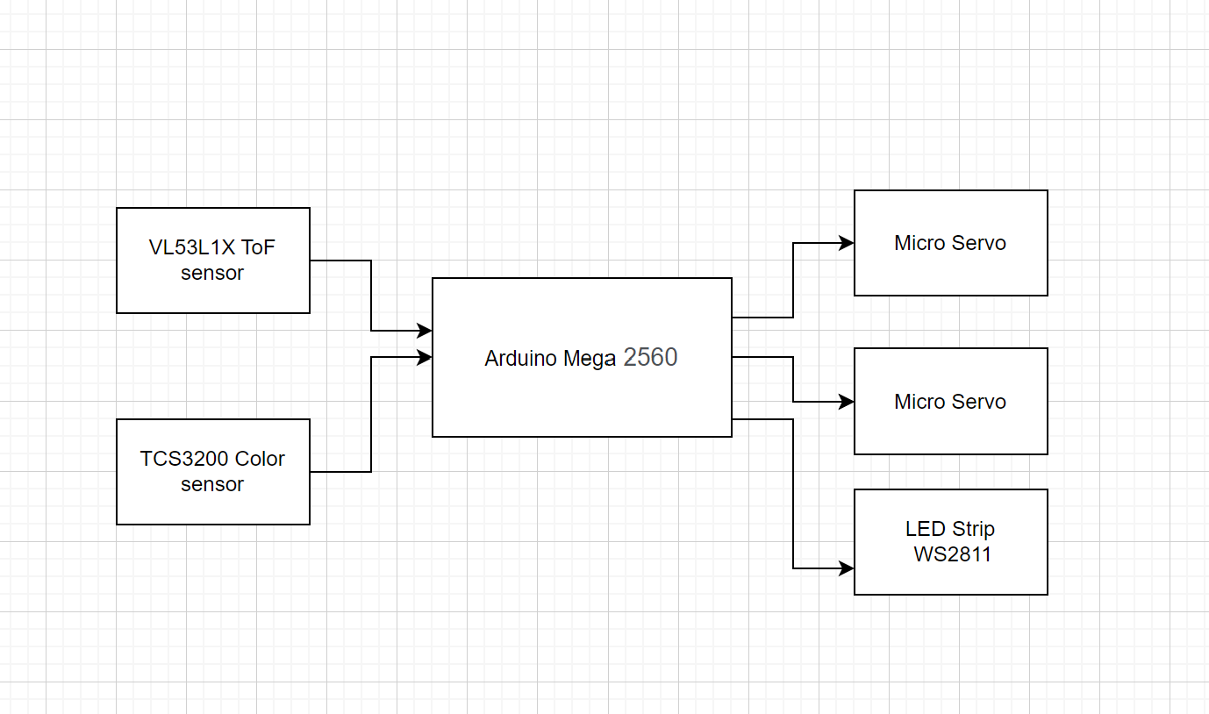

# Modules

I have organized the description of my solution into different modules that are logical, testable, and manageable. Each module consists of the Design, Implementation and Test phase. Module Arduino, color sensor, tof sensor, servos, lds, test of the system , hardware, conclusion

## Module 1 – Arduino MEGA 2560

### Module 1 Design

The**Arduino Mega 2560** is a microcontroller board based on the [ATmega2560](http://ww1.microchip.com/downloads/en/DeviceDoc/Atmel-2549-8-bit-AVR-Microcontroller-ATmega640-1280-1281-2560-2561_datasheet.pdf) chip. It contains 54 digital input/output pins (of which 15 can be used as PWM outputs), 16 analog inputs. “ I was chosen among other microcontrollers, because of many available pins, that are necessary to connect all the external input devices to the board. The operating voltage for this microcontroller 3.3 V or 5V that aligns with servo’s 4.0 - 7.2 V operating voltage, TCS3200 color sensor’ 2.7V t- 5.5V operating voltage, and VL53L1X Time-of-Flight Distance Sensor’s 2.6 V - 5.5 V operating voltage, so its voltage pins can be used to power the external equipment. Despite being size than other microcontrollers, the Arduino Mega board is still suitable for this project, as the machine will have 40 cm width and 50 cm hight.- to be changed. Maybe seed of the clock?

### Module 1 Implementation

The implementation of Arduino board is very simple. To check if the board is functional is necessary just connect the board with usb cable to the computer and open the ide environment, select the appropriate Arduino model and corresponding port. I tested its functionality by using Serial.print() function, and printed a short message on serial monitor.

### Module 1 Test

To test if Arduino Mega board is functional, I wrote a simple code, and displayed the message on the Serial Monitor.

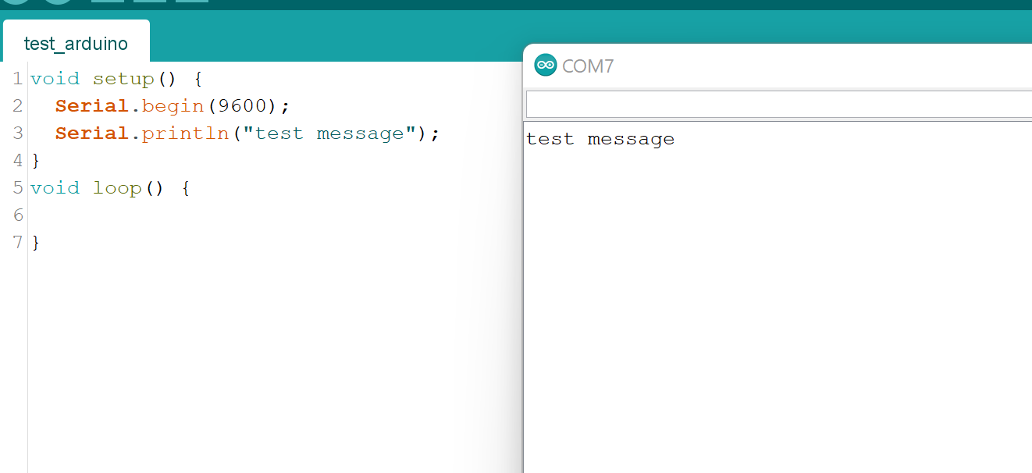

The quick test proved the basic functionality of the microcontroller, therefore is ready to implement further components.

## Module 2 – TCS3200 Color Sensor

### Module 3 Design

The TCS3200 color sensor is a light-to-frequency converter, consist of silicon photodiodes that can sense light, and a current-to-frequency converter. It consists of four: red, green, blue, and clear filters. These converters produce a square wave output with a frequency proportional to the intensity of light detected by a sensor. This sensor was chosen, as is low cost, programmable, able to communicates Directly With a Microcontroller via digital input and output pins and small size, suitable for the dispenser. The operating voltage used for this sensor is 5V. Usually the output frequency belong to the range between 2Hz - 500KHz. By outputs S1, and S0 connected to Arduino board, is possible to choose a frequency values: 2%, 20% or 100%,

### 5.2.2 Module 3 Implementation

### 5.2.3 Module 3 Test

## Module 3 – Servo Micro Motor

### Module 3 Design

To build rotating mechanism of the machine the two Micro Servos SG90 Towerpro were used. Described Servo can rotate approximately 180 degrees (90 in each direction). The servos are controlled with Pulse Width Modulation, The Arduino board generates a PWM signal on the specified pin, and the servo interprets the duration of the pulse to determine the angle of rotation. By adjusting the duration of the pulse, the servo can be positioned to different angles. The range of motion is crucial for the machine to move precisely 45 degrees to the right or left in order to position candies at right angles based on their detected color.

### 5.3.2 Module 3 Implementation

Microservos were connected according to their pinout, to the shared power source of 5V, common ground, and digital pins 9 and 10.In order to implement servos into the machine, the right angles have to be measured, for both top and bottom servos.

### 5.3.3 Module 3 Test

The first test of the servos was made to check their basic functionality and the pins to which they were connected, for this purpose a short code was written and uploaded to the Arduino board. The test checked if the servos moved to chosen angles, and for any possible errors with the implementation of the code. The Servo library was implemented for precise and efficient control of both motors.

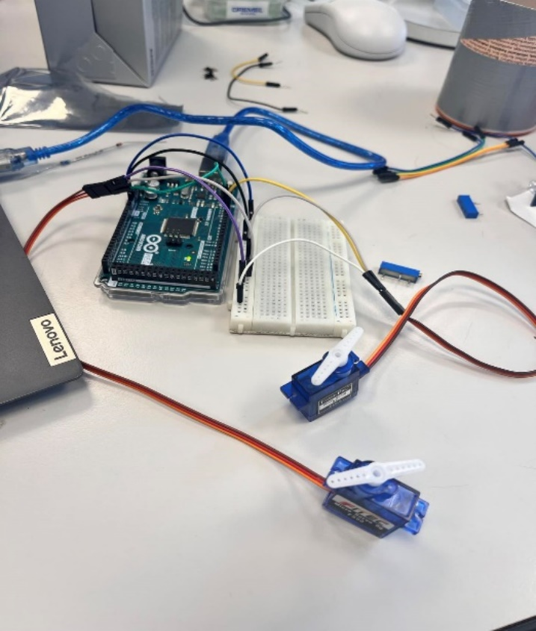

After conducting a successful functionality test, servos were implemented to the prototype of the machine in order to choose the right scope of movement of each servo and adjust the right angles and delays necessary for the main code of the program.

## 5.4 Module 4 - VL53L1X Time-of-Flight Distance Sensor

### 5.4.1 Module 4 Design

### 5.4.2 Module 4 Implementation

### 5.4.3 Module 4 Test

## 5.5 Module 5 - WS2811 5050 RGB LED Strip

### 5.5.1 Module 5 Design

### 5.5.2 Module 5 Implementation

### 5.5.3 Module 5 Test

# 6. System Integration

## 6.1 Design

Flow chart

## 6.2 Implementation

## 6.3 Test

# 7. Prove

# 8. Perspective/ Reflections

# 9. Conclusion

# 10. Appendices